CHOOSING THE RIGHT APPROACH TO CAPTURE THE PRODUCT VISION
The product vision plays a crucial part in achieving product success: It sets a shared direction and helps create strong alignment. Despite its importance, there are two competing views of what a product vision is and how it should be captured. In this article, we discuss the different approaches and explain which one we recommend.
Option 1: The Vision Captures Strategic Decisions
Your first option is to view the product vision as a statement that captures strategic decisions like the product’s users and customers, its value proposition, and its standout features. A popular template to capture such a vision is the formula developed by Geoffrey Moore in his book Crossing the Chasm:
For (target customers …)
Who are dissatisfied with (the current market alternative)
Our product is a (new product category)
That provides (key problem-solving capability).
Unlike (the product alternative),
We have assembled (key whole product feature for your specific application).

Let’s apply this template to a sample product that helps people reduce the risk of developing type-two diabetes. The resulting statement might look like this:

For middle-aged men with busy jobs and unhealthy eating habits who own a smartwatch and a smart scale
Who are dissatisfied with the limitations of current healthy-eating products
Our product is an AI-powered digital eating coach
That provides personalised advice to improve eating habits and significantly reduce the risk of developing type-two diabetes.
Unlike MyFitnessPal, Fooducate, and Glucose Buddy
We have assembled a smart, personalised, and fully integrated solution.

While I’ve seen people use variations of Moore’s original template stated above, the resulting visions don’t focus on the product’s purpose—the main reason for offering it. Instead, they describe who the product is for and how it differs from competing offerings. This is hardly surprising, as Moore describes the template as an effective way to position the product, but not to express its vision.
Option 2: The Vision Describes a Big, Aspirational Goal
Your second option is to regard the vision as an aspirational goal that describes the ultimate reason for creating the product and the positive change it should bring about. For the sample product mentioned above, the vision might simply be:
HEALTHY EATING
The benefit of using such a vision is that it acts as a big, motivational goal—a shared purpose that guides and aligns the stakeholders and development teams and that helps them understand how their work creates a positive impact and relates to a bigger whole.
If you choose this option, then your vision should fulfil the following six criteria, which we explain in more detail in my article Six Qualities of a Great Product Vision.
- Inspiring: The vision resonates with the stakeholders and development teams.
- Shared: The individuals support the vision.
- Ethical: The vision gives rise to a product that does not cause any harm to people and the planet.
- Concise: The vision is captured as a memorable statement or slogan.
- Ambitious: The vision is a big, hairy, audacious goal that might never be fully achieved.
- Enduring: The vision provides guidance for at least the next five years.

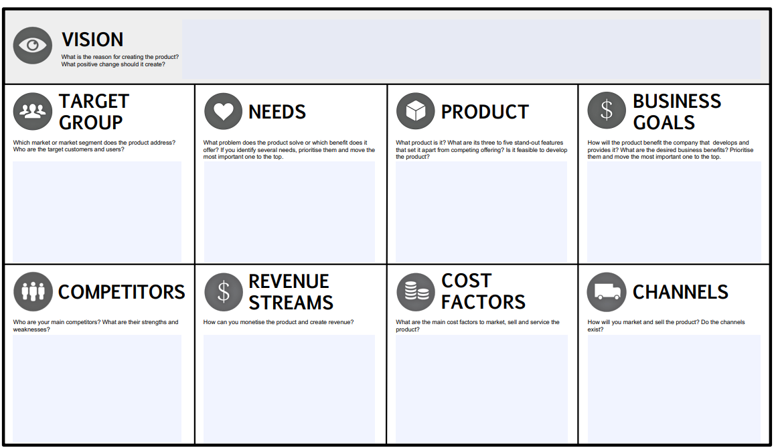
In the template above, the product vision is captured in the top section and the strategy is stated in the bottom four ones. These consist of the target group—the users and customers of the product, the needs, which capture the problem the product should address or the benefit it should create, the product with its standout features, and the business goals, which describe the benefits the product should generate for the company providing it.
Applying the tool to capture the vision and strategy of the sample diabetes product results in the following artefact.
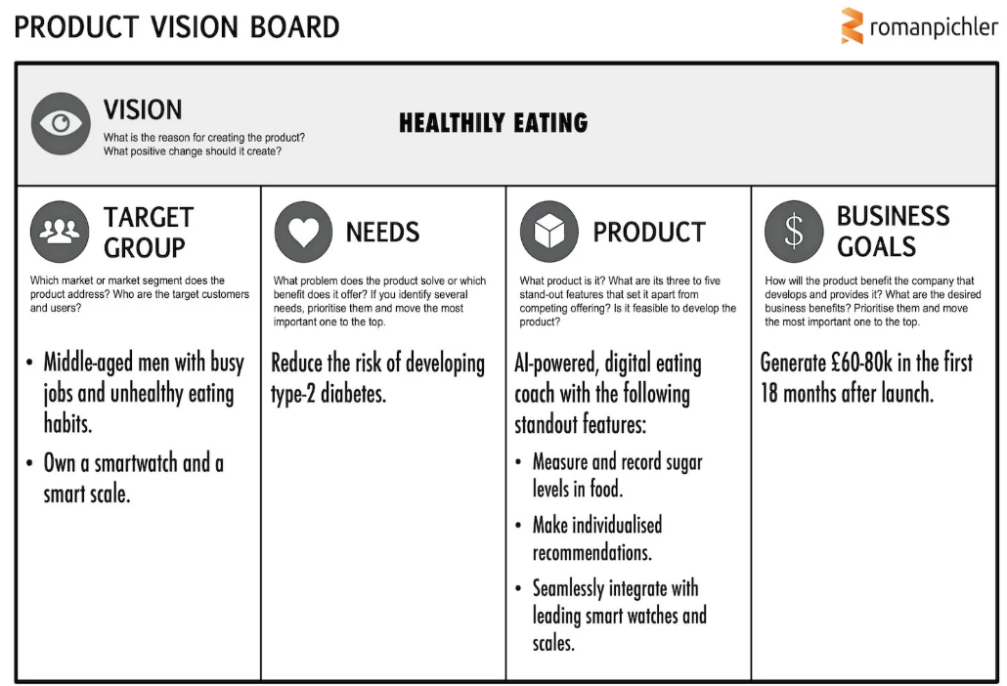

The product vision board above contains similar information as the sample vision statement we shared earlier based Moore’s template. Note, though, that it adds the ultimate reason for creating the product as well as a business goal. Additionally, it structures and visualises the information instead of using one long sentence.

